Beer Name: Walnut Brown Ale
Brew Date: Apr 8 ‘20
Batch Size: 10 gal
Target OG/◦P: 1.067
Amnt lb/kg Ingredient
16 # Pale
8 # Bisquit
1.5 # Crystal 60-80L
2 # Wheat
1 # Brown
2 c Toasted walnuts
1 Tsp NaCl (mash)
1 tsp NaCl(sparge)
5 Tsp Sprchrg
Irish Moss
Nottingham

Qt oz/g Hop/Seasoning Time
56 g NB 60 min
75 g NB 15 min

Stage Date
Primary:
Racked:
Racked:
Bottled:
Kegged:
Re-Kegged:
Purged: Charged:

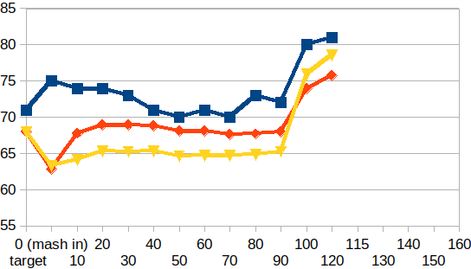

Start Time:6:45am
Fill mash tun:
Fill sparge kettle:
Fire burners: 6:45am
Heat Mash Tun : Target Temp: 68
Heat Sparge Kettle: Target Temp: 72
Target Temp (Mash): 67
Grind grain: 7:05 am
sparge temp: 72
Strike Temp: 71.9
pump temp:
Mash in: 62.8
Mash: Duration: 90 minutes
Start: 7:35am Finish:am
Heat (to deactivate enzymes)
Target Temp: 75.5
Start: 9:05am
Finish: 9:25
Heat Sparge H20 (Target81◦)
Sparge: Start:
Finish:10:25
Wort collected: full kettle
Boil : Burner On:
Rolling Boil: 10:45am
Hops In: 11:15am
Whirlflock in: 12pm Hops in: 12pm
Duration: 90 min Start: 10:45am
Finish: 12:15pm
Burner Off: 12:16
Rest 15 min
Pump and chill:
Start: 12:31 Finish: pm
OG : 1.067
Yeast: Nottingham
Irish Moss

Notes:

